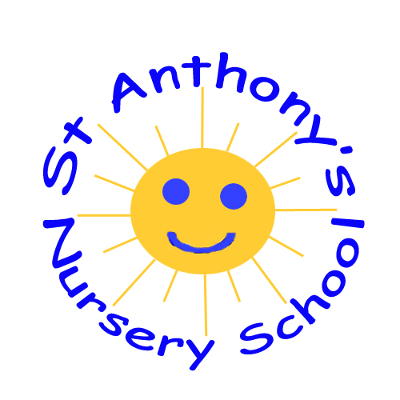ST ANTHONY’S NURSERY SCHHOL
ADMISSIONS POLICY

In St Anthony’s Nursery, as a CCMS school, we follow an Open Door Policy to ensure our Nursery is accessible to children and families from all sections of the local community.
To do this we will;
- Ensure that the Nursery is widely known in the local community. We will place advertising notices in the press and in areas where all sections of the community can see them.
- Arrange our admissions criteria in conjunction with the EA Statutory Requirements followed by the Nursery’s sub criteria which is agreed upon by our Board Of Governors.

Open Enrolment Admissions Information is overleaf.
- If the full compliment of 52 pre-school 4 year olds is not reached, then places will be allocated to children in their penultimate pre-school year in accordance with chronological age beginning with the eldest child.
- In our practice, as a CCMS Nursery School, we have an open door welcoming policy for parents/ guardians and family members from all cultural, ethnic, and religious groups with and without disabilities
- We make our Equal Opportunities Policy widely known.
- We are flexible about attendance patterns in order to accommodate the needs of individual children and their families.
We consult with local parent/ guardian and support groups to ensure that the Nursery will continue to meet the changing needs of its catchment area and the local community.

