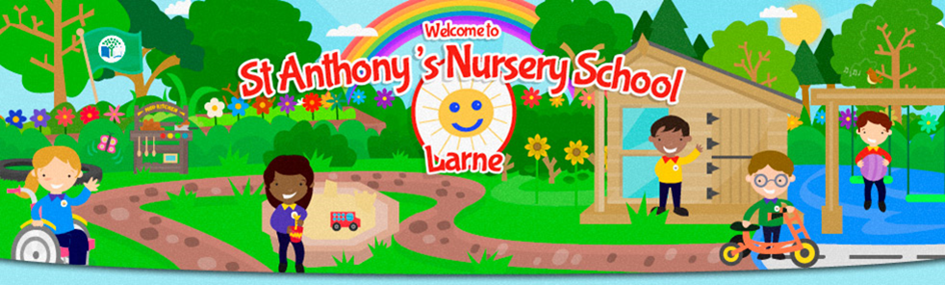
St Anthony's Nursery School
Newsletter - September 2023
Hello Girls and Boys, Parents and Guardians, welcome to St Anthony's Nursery School.
We would like to take this opportunity to introduce Mrs Marie-Claire McIlroy, who is taking over as the role as acting principal until the new principal is appointed.
We are delighted to welcome back Mrs Roisin Gamble, who is returning to teach in the Rainbow room from Monday-Thursday. Miss Rebecca Gray will be the teacher in the Rainbow room every Friday.
We hope your child will settle quickly into Nursery life and will enjoy the variety of learning opportunities that we provide. As a team, we will endeavour to make your child's Nursery year enjoyable and rewarding for all.

Our learning focus this month is 'Settling Into My New School’ We subtly and positively strengthen and build on the Nursery routines and Golden Rules and talk about our new friends, our teachers and how our Nursery Day runs, on a daily basis.
Monthly Newsletters
As part of our Eco School initiatives to save paper etc, all newsletters will be emailed to you, using the email address you provided. Please keep us informed of any changes to this email address/es and if you do not receive your Newsletter at the start of each month, please contact our Secretary, Roisin, to check we have your correct email address details. Our newsletters and dinner menus are also on our website.
www.stanthonysnurseryschool.com
Settling In
During the next few weeks, we will be concentrating on helping the children to settle and 'fly solo'. To do so, the children are introduced gradually to Nursery life and new friends. This is a big step for your child, and it is important we don't rush the children too fast, too soon - slow and steady wins the race! Therefore, we will have guidelines for collection on an individual basis during September and October. The extension of the children's Nursery times is at the discretion of their teacher and based on how each child is adapting to Nursery. Children need to be fully toilet trained and able to follow sanitising and hand washing routines meaning that hygiene levels are high as cross contamination can unfortunately happen easily in a Nursery setting.
Each child is very different and reacts uniquely to the Nursery environment - staff will keep you informed regarding your child's collection time. If you have any concerns, please ring, or email the office.
Drawers/ Water Bottles
Each child has their own drawer with their special symbol. This is where the children will keep their art work to bring home as well as eg their sun hat and any items from home.
Your child should bring a re-useable water bottle every day, this can be topped up in school from the water fountain in each classroom and brought home each day to return the next day. Please ensure you write your child’s name on it and that your child will be able to recognise their own bottle.
Please encourage your child NOT to bring toys into Nursery as they can be lost or broken and cause upset.

Nursery Fund
As you will be aware through the media, school budgets decreasing, and overheads are drastically increasing. As you can imagine, this impacts on what we can provide for our children. Your weekly contribution of £5 (equates to £1 per day) helps us to provide many essentials and extras for your child eg snacks, resources, coaches, visits etc to name but a few. We are aware of the current financial climate and if there is anyone unable to contribute weekly, please speak to a staff member and alternative arrangements can be made. For banking reasons, Nursery Fund should be paid on a Monday morning in a clearly named envelope. It is also possible to pay fortnightly or monthly should you wish. Brown envelopes are provided for your use, and we ask that you drop these into the basket where your child enters Nursery. We are very grateful for your support.
Free School Meals
If you believe your child is entitled to free school meal, please apply online to EA. The Nursery must receive notification from the Education Authority before your child can claim free school meals. If we have not received this notification, school meals will need to be paid for, £2.50 per day. It is School Policy that if school meals have not been paid for two days, the parent/guardian will be contacted, and no meals can be provided until payment is brought up to date.
If your child is entitled to free school meals, please complete a form online through the EA website. Whether your child wishes to avail of the meal or not we would ask that you apply as this effects our school budget. This would be very beneficial to the Nursery.

Allergies
We have a number of children who have a serious allergy to Nuts- please ensure, when sending in a packed lunch, that nuts are not present in any form eg chocolate spread, biscuits etc
If your child has any food allergies that may affect the preparation of their school meal, the School Kitchen Service will require a letter from your GP/ Specialist stating their allergy before special arrangements can be made.

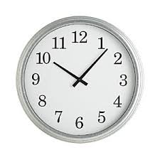
Collection Times for September & October
Nursery times will be different each week during the month of September/October. Please ensure you know the time when your child is to be picked up. All dates/times have been notified to you in writing in your child's Starting School Pack.
Please keep staff informed of any new family members or friends/ carers who will be collecting your child from school. Please ring the school on 028 2827 8645 or inform a member of staff in person.
Reminder- anyone collecting your child must be over 16
Asthma & Allergies - As your child's health and wellbeing is a priority, parents/ guardians are required to fill in a form requesting medication be given in school.
Parents/guardians are required to get Epi Pens & inhalers from your GP, which will be kept permanently in school. Please label these clearly. It is your responsibility to take note of the expiry date and ensure the Nursery is kept up to date of any developments/changes in your child's medical condition.
Hand Washing & Personal Hygiene
Even under normal circumstances, it is extremely important in Nursery that the children are able to follow hand washing and hygiene routines especially when we have children and staff with underlying medical conditions requiring the highest standards of hygiene and cleanliness to decrease chances of cross-infection.
We ask parents/ guardians to ensure their child can use the toilet independently, flush the toilet and wash their hands after toileting. We have hand sanitiser; automatic soap dispensers and paper towels and we will be teaching the children how to use these.
Tissues are available for runny noses - we ask that you enable your child to use a tissue for themselves and dispose of after use and then wash their hands- Catch It, Bin It, Kill It
In a normal year, bouts of sickness or childhood infections occur in Nursery. We ask you to ensure that your child is fully well enough to attend Nursery. A child being sent unwell into school, puts other children's and our staff's health at risk.
It is HSC requirement that children must be kept off Nursery for 48 hours after a vomiting/diarrhoea incident.
Admission Information
Many thanks for being so prompt returning emergency contact information etc. For those who have not done so yet please return your forms as soon as possible. It is very important we have this information on file whilst your child is in our care. Remember it is your responsibility to ensure that you keep us updated on changes regarding telephone numbers and persons collecting your child.

Arrivals and Departures
As part of Our Child Protection Policy and for the safety of your child we would appreciate your co-operation with the following –
- Please bring your child to their Nursery entrance in the mornings where the staff will greet you both.

- Doors will open for arrival at 8.55am to avoid long queues coming into school. You will appreciate it will take a few moments as the children enter with their belongings, sanitise, and hang up their coats.
- Doors will open for home time at 1.25pm to again facilitate a more staggered collection, The children are excited to see their parents/ guardians at home time but it is important that we ensure your child is safely delivered into your hands.
- Bigger brothers, sisters, cousins, or friends who are not over 16 years of age are not allowed to bring/collect your child from the classroom even if you are sitting in the car park. Thank you for your co-operation.

The Driveway Entrance & Car Park
Please do not park and wait directly outside the Nursery as this causes an obstruction for other drivers and could potentially harm the safety of our children or their families. The entrance to our Nursery is not only used by us but also St. Anthony’s Primary School, delivery vehicles and school buses and must be kept clear in case of an emergency vehicle needing access There is a one-way system in operation in the car-park with a speed limit of 5mph.
Please proceed with caution and be alert to small children entering and exiting cars and walking around the carpark
Please respect the Disabled Parking space at the Nursery and ensure it is not blocked or restricts e.g., wheelchair access

Text Service
We have a parent/ guardian text service to keep you informed of important dates/reminders etc. Please ensure we always have an up-to-date telephone number for you. You will receive a notification at beginning of Sept to register into a School App, this is the text service we use. An email will be sent to let you know when this will happen.

-------------------------------------------------------------------------------------------------------------------
Happy 4th Birthday to
Fraser, Nuala, Ben, Hollie Mia,
Zara, Ernie & William,
Edward, Sophie, Blake, Emma

Rhymes & Songs
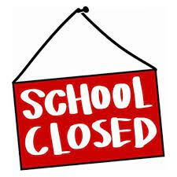
You can support the development of your child's literacy by saying and singing our monthly rhymes & songs, attached with each Newsletter.

Nursery is closed on Mon 25th Sept

MacMillan Coffee Morning - Friday 29th September
MacMillan Cancer Support is a cause close to our hearts here in the Nursery. We will be making buns with the children. If you would like to make a donation, we ask that you add this to your child's brown envelope and clearly mark name/ amount and what the money is for.

Wear Green Colour Day- Fri 29th Sept.
At the end of every month, we hold a Colour Day. On 29th Sept children are free to wear their favourite coloured clothes into school instead of uniform. We ask for a £1 donation towards School Funds. This can be dropped into the tin at your child’s entrance or put / clearly marked in their weekly brown envelope.

Social Media - As confidentiality is of utmost importance, our school policy requires that staff may not be 'friends' with parents/guardians on any form of social media. Thank you for your co-operation.
Once you have signed up to See Saw, (you will receive your child's unique joining code when they start Nursery) we will be sending you photos of your child being busy and having fun in their learning. Other children, and indeed staff, may also be in these photos and it is important that these photos are not shared on social media without the consent of those children's parents/ guardians or our staff.

Don't forget, if you have any queries or concerns, please speak to the Principal or contact us on
028 2827 8645 or by email at stanthonysnursery@yahoo.co.uk

We look forward to a wonderful year of working in
partnership with you.

September Songs and Rhymes
Twinkle, Twinkle
Twinkle, twinkle, little star
How I wonder what you are
Up above the world so high
Like a diamond in the sky
Twinkle, twinkle little star
How I wonder what you are.

Humpty Dumpty

Humpty Dumpty sat on a wall,
Humpty Dumpty had a great fall.
All the King's horses, and all the King's men
Couldn't put Humpty together again!

Incy Wincy Spider
Incy Wincy spider climbs up the water spout.
Down came the rain and washed the spider out. Out came the sunshine and dried up all the rain,
And Incy Wincy spider climbed up the spout again.

The Listening Song (to tune of Frere Jaques)
Eyes are watching,
Ears are listening,
Lips are closed,
Hands are still.
Feet are very quiet,
You should really try it.
Listening well
Listening well

