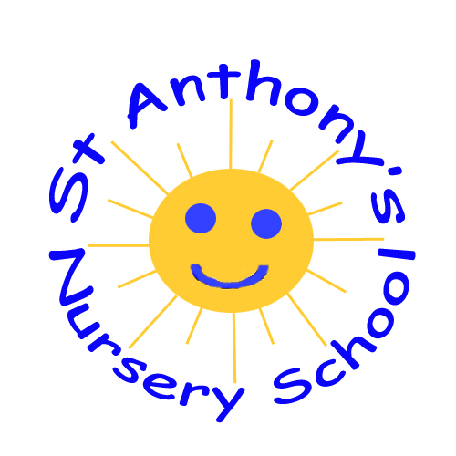

October Newsletter 2023
Dear Parents/Carers,
We are delighted with how our children have settled into Nursery. They are learning so many new routines, making friends and having lots of fun. We look forward to working in partnership with you throughout the year and getting to know you and your child better. We will be arranging a settling in meeting with you to discuss your child's progress before the mid-term break. Please see the following dates for your diary.
If you have any queries, please contact the office on 02828278645 or by email: stanthonysnursery@yahoo.co.uk
We will continue to keep you updated throughout the year via text messages and emails. Please ensure we have updated numbers and emails and that you check regularly.
Many thanks,
Marie-Claire McIlroy
- Halloween party Friday 27th October: children can come into school wearing a costume if they wish. There are no dinners/lunches as school finishes at 1100
- School closed from Monday 30th October until Tuesday 7th November
- Settling in meetings: Thursday 19th October -Mrs Gamble's class
- Tuesday 24th October- Mrs McIlroy's class
- Monday 9th October: Dinners/Lunches start. Please see email regarding dinner routine
- Tuesday 24th October: Gary the gardener in school planting seeds with children.

Theme: Autumn/Halloween
- identifying Autumnal colours-orange, yellow and brown
- discussing changes in seasons-falling leaves, conkers, berries on trees
- singing autumn and Halloween songs
- settling into new Nursery routines
- Halloween party on Friday 27th October
- School finishes at 11.00
- There will be no dinners/lunches on this day
- Children can wear costumes which are child friendly
- Donations towards nursery funds are greatly appreciated

Settling in meetings
- Mrs Gamble's class- Thursday 19th October
- Mrs McIlroy's class-Tuesday 24th October
- Settling in meetings will be done via telephone unless a face-to-face meeting has been previously organised
- Please see your child's teacher and complete the class sheet to request a preferred time slot. We will do our utmost to facilitate your request
- Meetings will last between 5-10 minutes. If more time is needed, a further appointment will be arranged
Some of the songs we are learning:
- Leaves Are Falling Rhyme | Nursery Rhymes |Action Songs/Rhymes |Pre Primary Rhymes | Kakarla Sisters - YouTube
- I'm a Little Pumpkin (to the tune of Little Tea Pot) - YouTube
- Please refrain from sharing pictures of your child on social media or to anyone else in keeping with our Child Protection Policy
- We are delighted to welcome Miss Blair into our nursery who will be the teacher in the Rainbow Room every Friday
- We raised £153.30 for Macmillan coffee morning on Friday 29th September. Thank you for all your kind donations!

