Final December newsletter
Dear Parents/ Guardians,
As we move towards the end of our first term, we would like to give huge praise and appreciation to our wonderful children. They have settled so well into following new routines and have made so many new friends. We are extremely proud of all of them. We are busy preparing for our Christmas concert and getting our classrooms ready in case we have any special visitors.
Christmas is a wonderful time of year but sometimes for so many reasons it can be a difficult season. Due to the emotional and financial demands, it can also be a challenging time of year. For this reason, we would prefer not to receive presents/gifts from parents but suggest that you donate to a charity of your choice if you have the means to do so. Your support and kindness is more than enough.
On behalf of myself and the Board of Governors, I would also like to extend massive thanks to our wonderful staff who never cease to amaze us with their dedication and diligence. We would be lost without each of them. We are so grateful for the help and cooperation from staff, parents and local community who consistently contribute towards daily life, making St. Anthony's Nursery School a very special place for our children to learn and grow.
We would like to wish everyone a safe Christmas and peaceful new year.
Warm regards,
Marie-Claire McIlroy
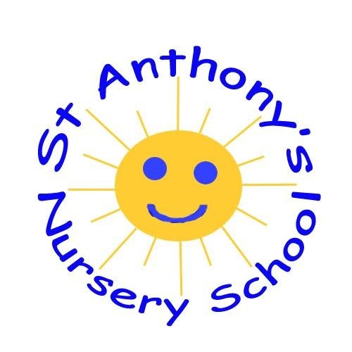
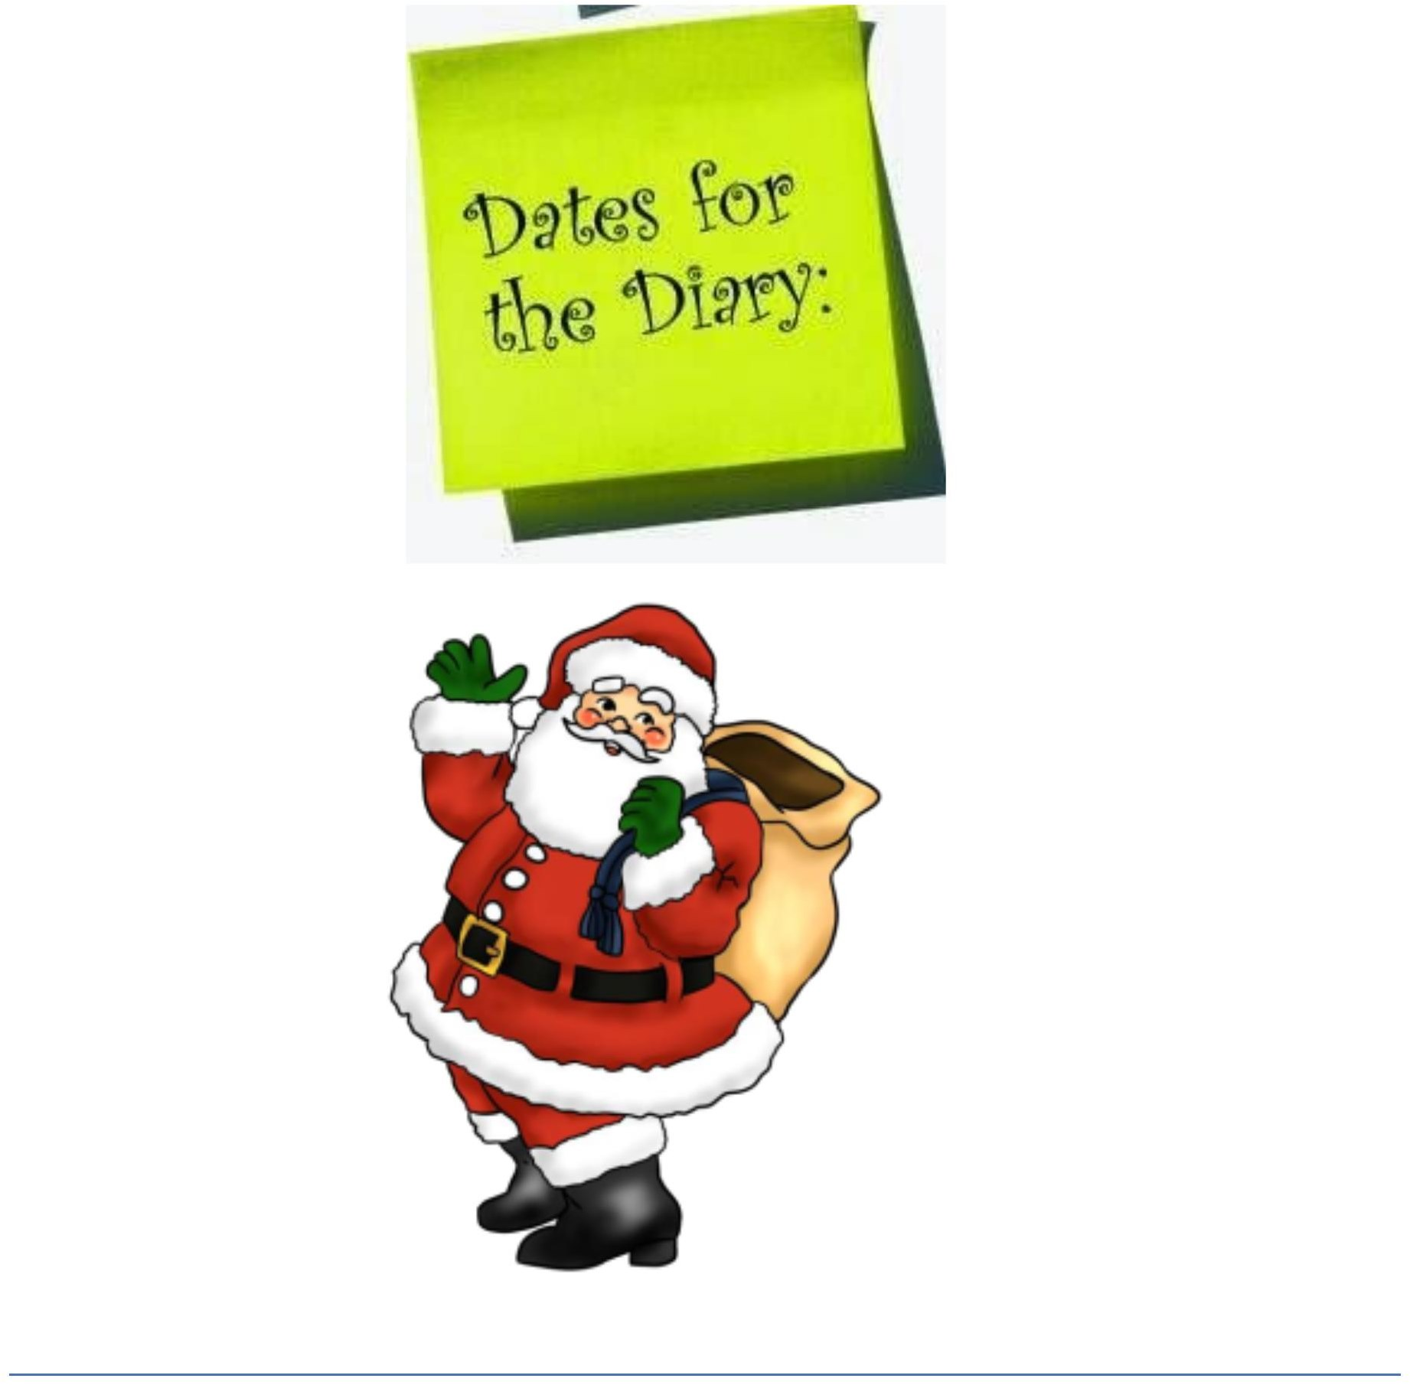
• Monday 4th, Tuesday 5th, Wednesday 6th December: Health visitor reviews in school.
• Thursday 7th December: Christmas dinner with a special visitor. Children can wear a Christmas jumper
• Wednesday 13th December: Mrs Gamble's class at 1100 **children go home straight after concert-no dinners/lunches for Rainbow Room (Normal school day for Butterfly Room)
• Thursday 14th December: Mrs McIlroy's class at 1100**children go home straight after concert-no dinners/lunches for Butterfly Room (Normal school day for Rainbow Room)
• Wednesday 20th December: Open day 2-4pm. School closed at 12pm. No dinners/lunches
• Thursday 21st December: Mr Hullaballoo in school for Christmas party. School finishes for Christmas holidays at 1.30pm
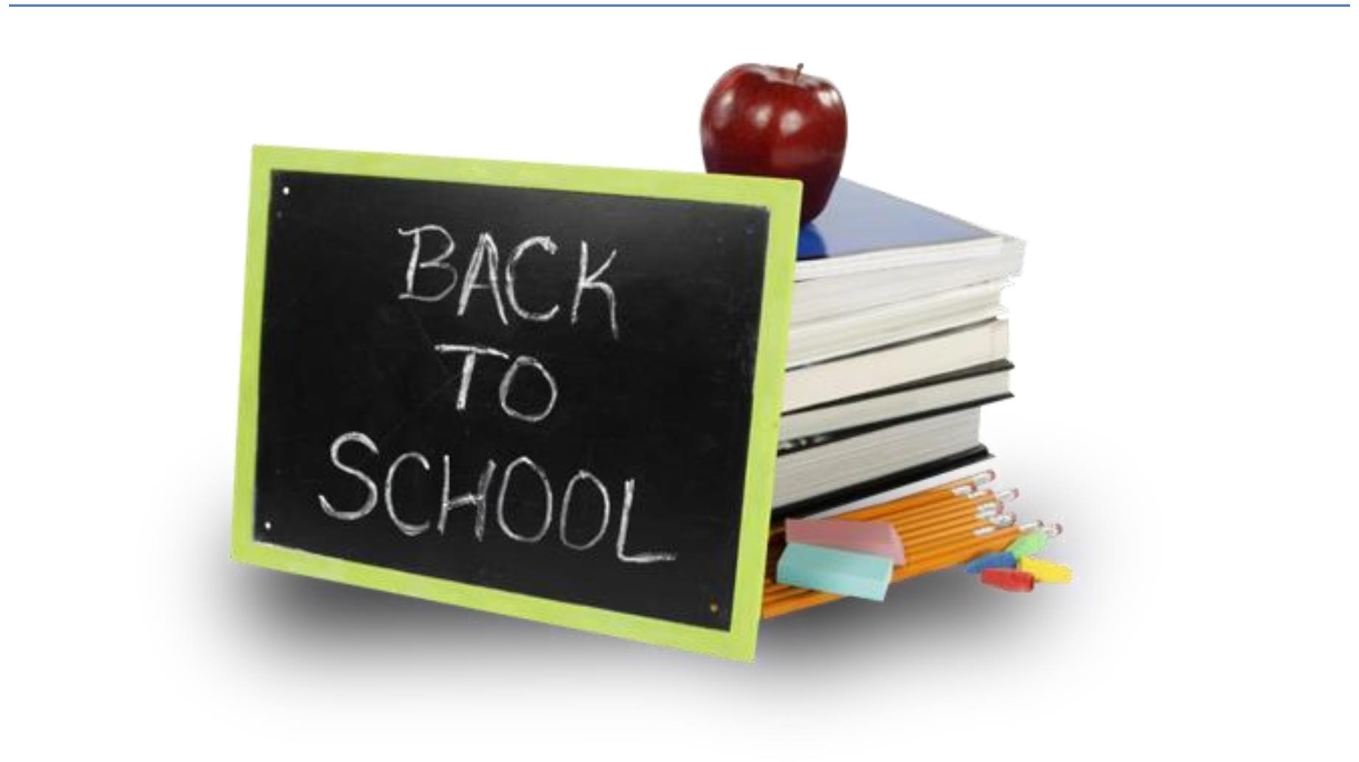
• Monday 8th January: School reopens to pupils and staff. Normal school day

Theme: Nativity and Christmas Celebrations
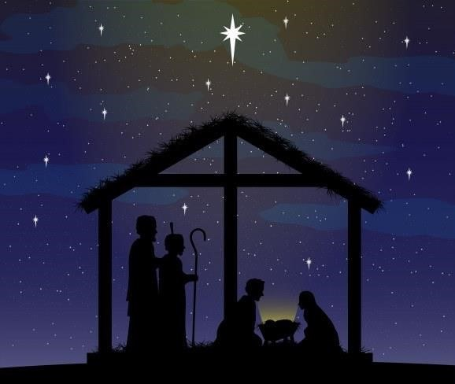
- This month we will be learning all about the story of the First Christmas
- Discussing preparations for Christmas
- Singing songs for our Nativity
- Identifying signs of Winter

Christmas Concert
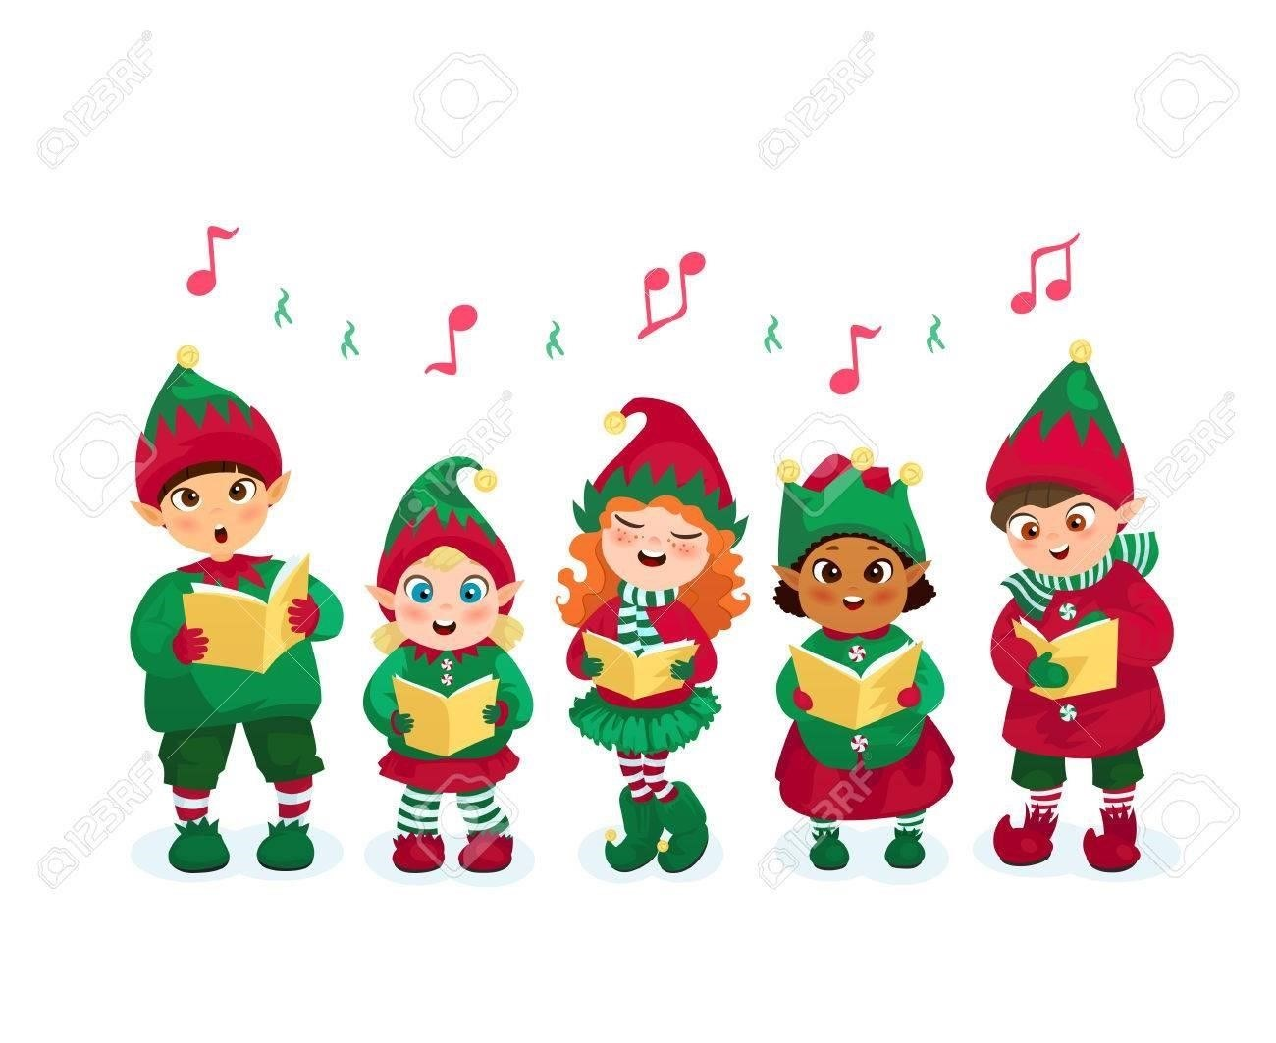
- Wednesday 13th December: Mrs Gamble's class at 1100 **children go home straight after concert-no dinners/lunches for Rainbow Room (Normal school day for Butterfly Room)
- Thursday 14th December: Mrs McIlroy's class at 1100**children go home straight after concert-no dinners/lunches for Butterfly Room (Normal school day for Rainbow Room)
- Due to limited space, please be aware that we only have space for 2 adults per child
- Please be mindful that this is many of our children's first experience of performing in front of others and it can become overwhelming for everyone . We would ask adults to refrain from uploading videos and photos to social media sites to protect the privacy of all children and staff

Wednesday 20th December
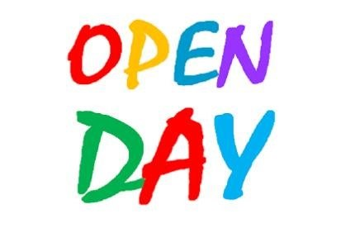
- School closes at 12pm to accommodate open day. No dinners/lunches on this day
- Open day 2-4pm. Please share with family and friends

Admissions
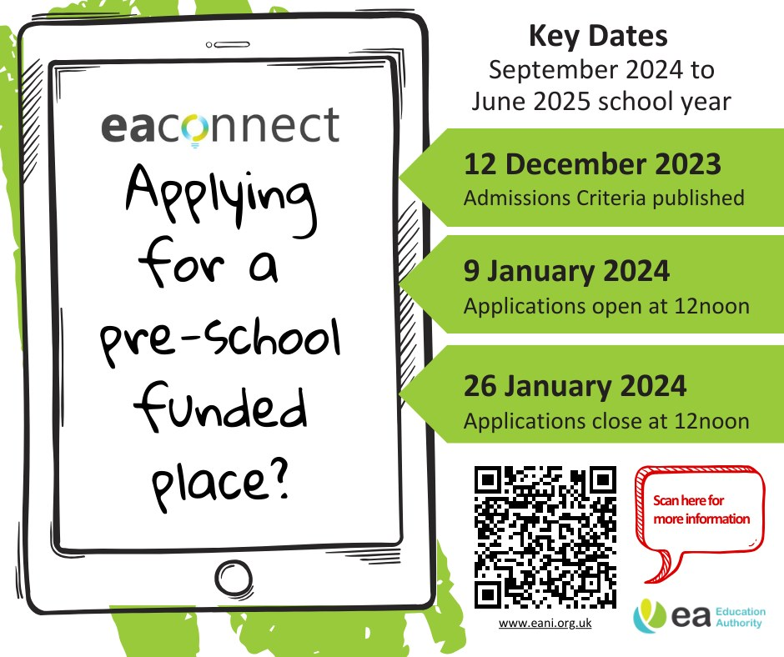

Christmas Dinner
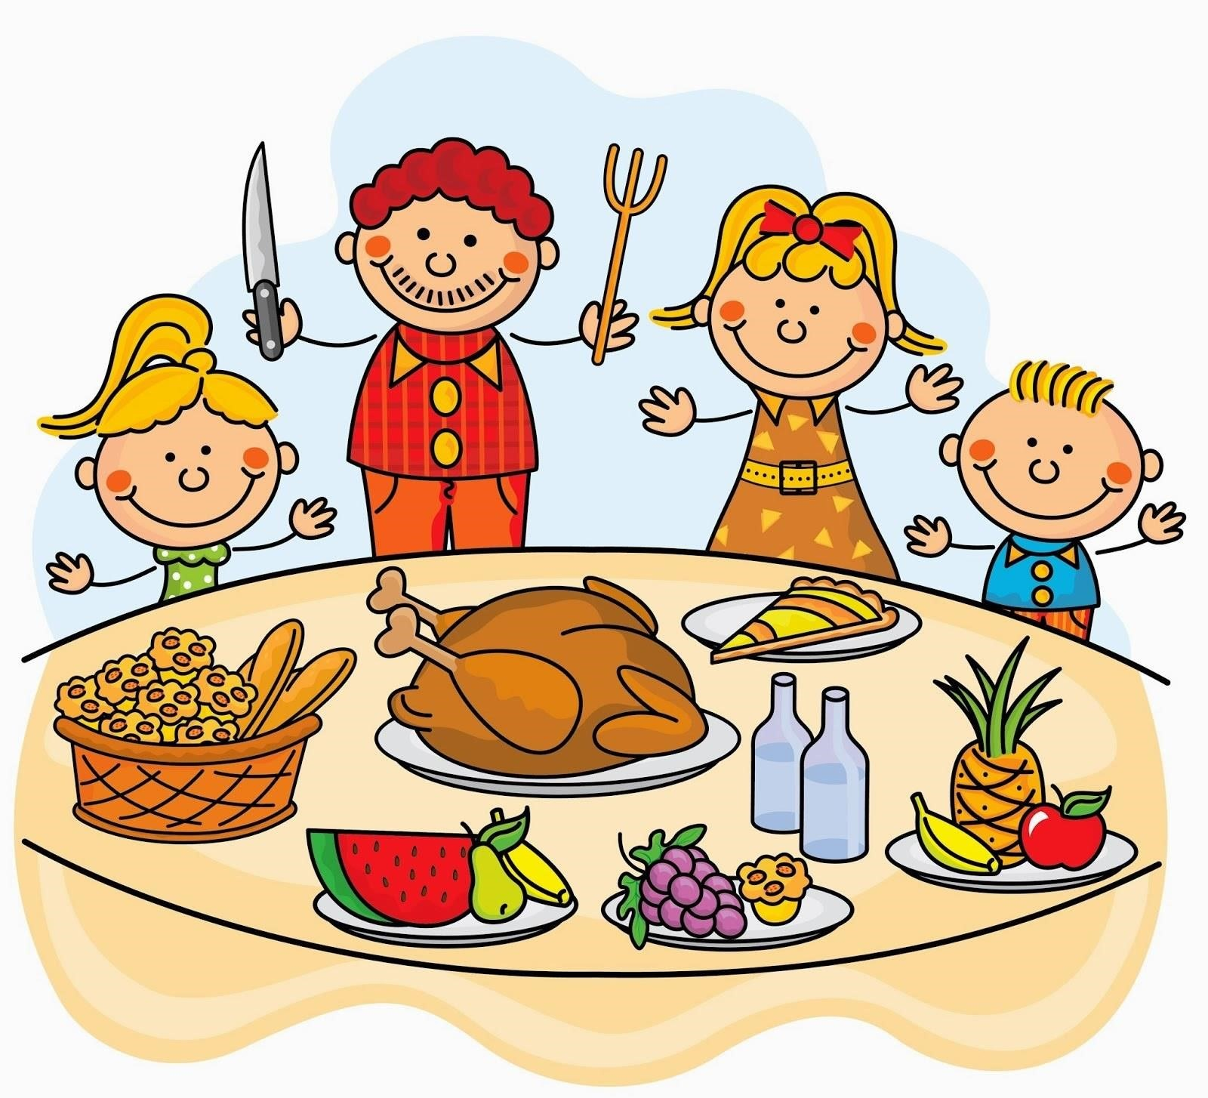
• Christmas Dinner on Thursday 7th December and we are hoping we have a special visitor if all the staff and children are on the nice list!
• Children can come to school wearing Christmas jumper in aid of Save the Children. All donations gratefully appreciated
• Dinner costs £2.50 as normal. Those entitled to FSM do not need to pay

Guess my name?
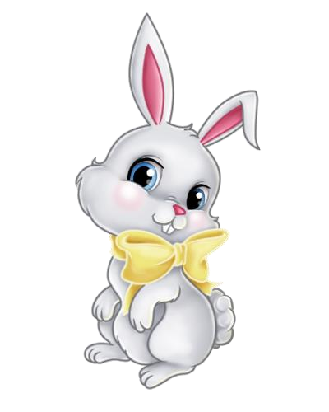
• Can you guess the name of the bunny?
• Please donate £1 per guess and give your child's name to a member of staff
• Winner will be announced on Thursday 7th December
• Many thanks to Nuala Davis' granny and Roisin Lavery's mummy for donating the prizes
• All donations towards nursery fund and gratefully appreciated

Stocking fillers
A few ideas for stocking fillers which will help extend your child's learning and develop their skills:
- scissors, playdough,
- crayons/colouring books,
- jigsaws, ball, stickers, books

Christmas cards for sale
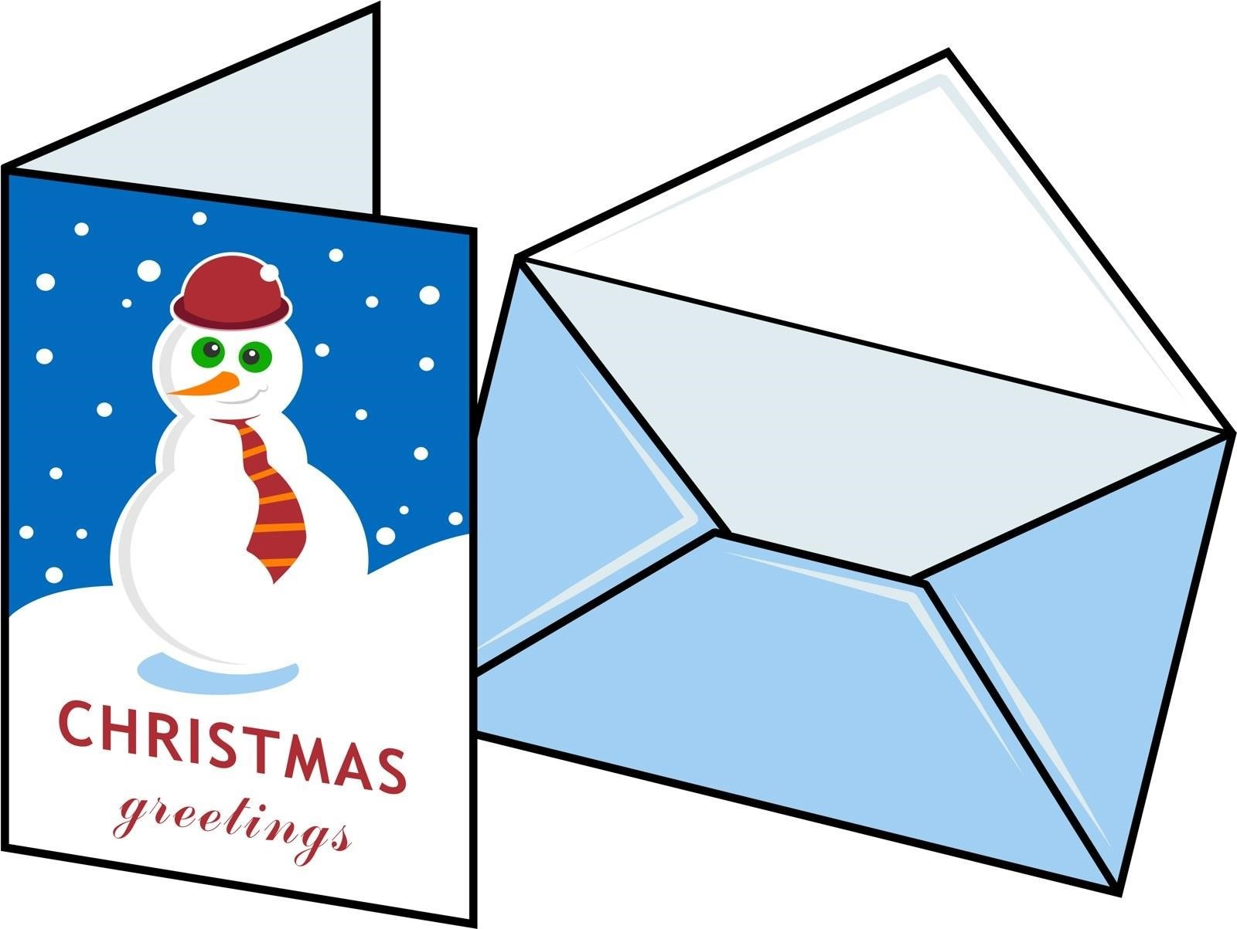
- Children are busy making personalised group Christmas cards which you can purchase if you would like
- £3 for a pack of 6 or £5 for a 2 packs
- If any of the children want to send cards to their friends, can we suggest they just sign their names and do not write individual names for everyone as it can become difficult to manage

From all your friends...
8th December: Lucy Gordon-Pharnam
24th December: Emma McDermott, Mary-Jane Quinn, Nancy Quinn
31st December: Annie McQuaid

Christmas songs
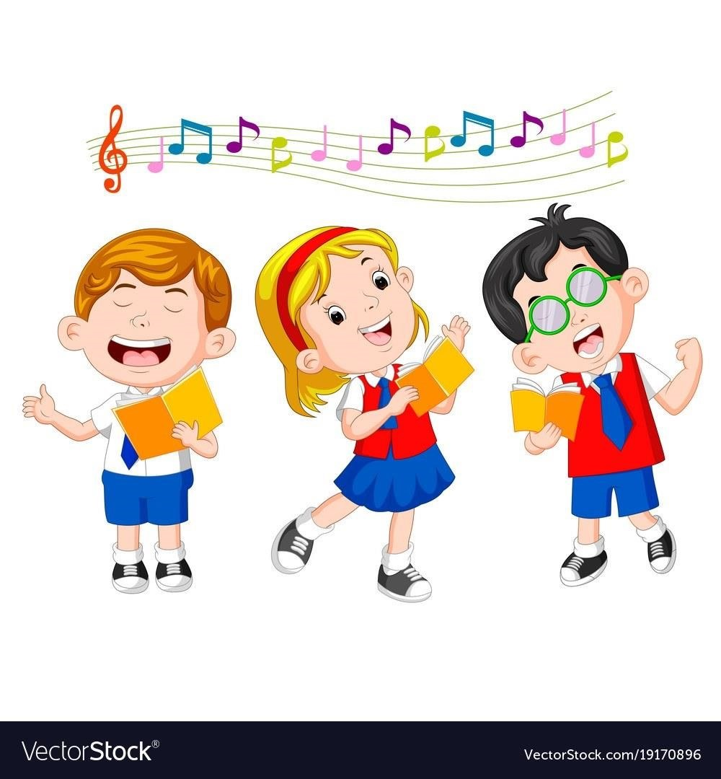
We hope you join in singing these songs at our concert:
- https://www.youtube.com/watch?v=0IcSuv9tZow
- https://www.youtube.com/watch?v=yCptBphqkwU
- https://www.youtube.com/watch?v=hNkvV4PR-q0

Contact Details
Phone: 02828278645
Email: stanthonysnursery@yahoo.co.uk

