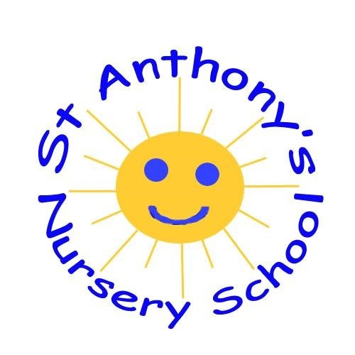
January newsletter
We would like to welcome all our children, parents and carers back to a new term and look forward to seeing all our friends again.
• Monday 8th January: School reopens to pupils and staff. Normal school day
- Tuesday 9th January: Admissions opens for pre-school and primary school at 1200
- https://www.eani.org.uk/parents/admissions/admissions-key-dates

- Thursday 18th January: Strike day-details to follow
- Friday 26th January: Admissions closes at 1200
- Friday 26th January: Big Garden Birdwatch

Theme: Outer Space and Cold Lands

Keeping healthy and staying active
- Jump, jiggle and jive are helping to keep us active despite the weather in January
- We are delighted to be able to start Playball sessions facilitated in St. Anthony's Primary School because of parental contributions to our Nursery Fund. Many thanks for all those who contribute.

Nursery Fund
- Please use the envelopes for your nursery fund of £5 per week or £25 until mid-term
- Thank you for all donations which are used to book activities and pay for extra resources for our children
- Please speak to a member of staff if you are unable to pay

Admissions
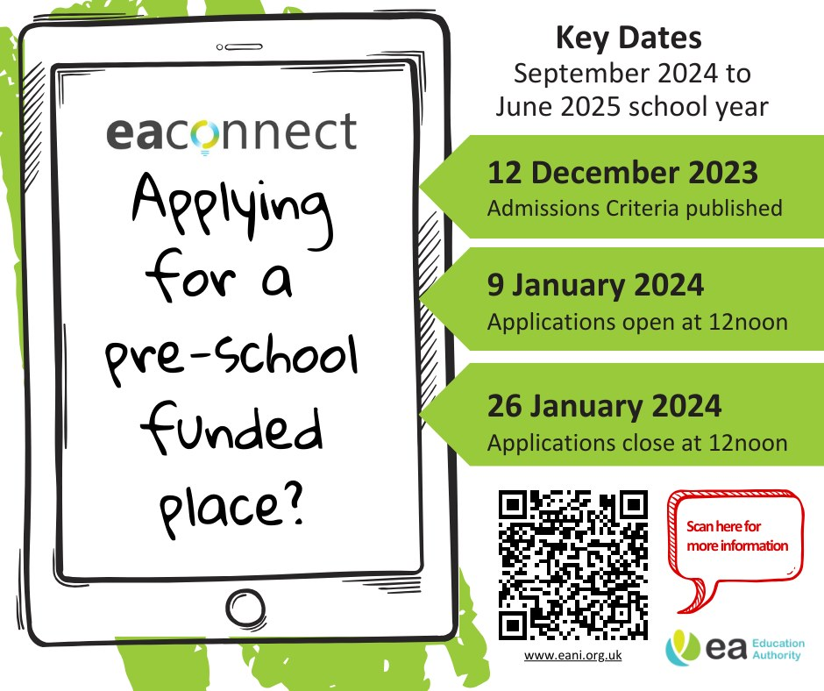

From all your friends...
21st January: Harrison McClay

Some songs for our topic
https://www.youtube.com/watch?v=2E3p_51tJx0
https://www.youtube.com/watch?v=cdMQOo0Ugtg

Contact Details
Phone: 02828278645
Email: stanthonysnursery@yahoo.co.uk

