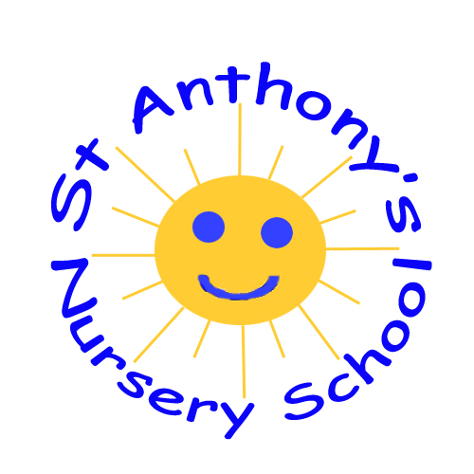 ST. ANTHONY'S NURSERY
HEALTHY EATING POLICY

RATIONALE
The Board of Governors and staff of St Anthony's Nursery School believe it is essential to provide our children with positive healthy eating experiences in order to promote their well being, educational performance and attainment and their long term health
"The relationship between poor health, nutrition and low school achievement is well documented."
"The Food in School Policy can only be truly effective within the context of a school that addresses personal development and emotional health and wellbeing and will work best when linked closely to physical education and physical activity in schools"
"Parents and those with parental responsibility are the primary influencers of, and have ultimate responsibility for, the eating habits of their children"
(Forward By Ministers in Food In Schools Policy Sept 2013- Every School a Good School).

We will endeavour to encourage our children's parents/guardians to look at the long term effects of a healthy and balanced diet. We respect the different dietary, cultural, ethical and health needs of all the children in our care. We are committed to promoting the holistic approach in entwining healthy eating with physical literacy and general personal, social and emotional literacy and well being.
St. Anthony's Nursery is involved in the Happy Healthy Kids programme funded through Getting Ready To Learn and the Board Of Governors and Staff are committed to continuing the programme in the best interests of our children.
St. Anthony's Nursery is involved with a named Health Visitor in the 3+ Review and the review appointment is carried out in school. The Nursery works hard to promote a good working relationship with our parents/guardians so that necessary information is willingly shared.
St Anthony's Nursery is involved in the Public Health Agency Tooth Brushing and Healthy Snacks Programme and work each year towards receiving their annual award.
IMPLEMENTATION OF THE HEALTHY EATING POLICY IN ST ANTHONY'S NURSERY
The Principal on behalf of the Board of Governors must ensure that:
- New members of staff including students and helpers, read copies of the Healthy Eating Policy and that this is discussed with them during their induction meeting.
- All staff, students and helpers are made fully aware of individual dietary needs and requirements.
- Children's individual dietary needs are confidential and not to be discussed outside of the nursery environment.
- The Healthy Eating Policy is made available to all parents/ guardians. Parents/guardians are informed during our Open Night meeting.
- The Nursery is up to date in following EA/ Department guidelines
- Staff attend food hygiene training where available
AVAILABILITY OF WATER
We have fresh drinking water available for children and staff at all times in our drinking fountain. Each child has their own cup and is encouraged to help themselves throughout the day as well as at snack and lunch/dinner times.
Staff will role model and encourage children to drink water throughout the day with support or independently.
We support the children in recognizing that they need to drink water when they are thirsty, hot or tired, or feeling unwell.
Only water and milk are permitted as lunch box drinks

MEALS
- Parents have the choice of a school cooked meal or home packed lunch for their child at midday.

The meals are cooked in St Anthony's Primary School and transported to the Nursery kitchen by bus.

- The Nursery meals comply with current government standards and guidelines.

- The Dinner Supervisor ensures that the meals are served hygienically and appropriately and children have washed their hands before eating.

- Lunch Boxes -We encourage parents/guardians to provide healthy lunches avoiding crisps, sweets, chocolate on a daily basis. We recommend that children have a maximum of 4 pieces of lunch eg bread/ fruit/ yogurt/ small treat- preferably not chocolate
As an Eco School we are very concerned with responsible packaging and so discourage the use of single use plastics and encourage parents/guardians to send food in re usable tubs and containers. This cuts down on waste and is ultimately cheaper. Plastic spoons are not permitted.
Left over food will be sent home so that parents/ guardians are aware of what their child has/ hasn't eaten

Water and milk may be provided from home for a drink or can be provided by the Nursery- fizzy drinks, juices etc are not permitted. Drinks should be in reusable bottles and plastic straws are not permitted

- Parents/guardians are able to choose between a cooked meal or home lunch for their child on a daily basis

MILK
Children under 5 are entitled to free milk and milk is provided at snack time and dinner/ lunch time in the Nursery
Milk may be sent from home for children having a packed lunch or can be provided by the Nursery
Parents/ guardians whose children have a milk allergy are asked to send milk alternatives into school if they wish. These are not provided free to schools.

CULTURAL RELIGIOUS/ ETHICAL REQUIREMNTS
- As Board of Governors and staff we respect and make arrangements for children's cultural, religious and ethical needs/ choices.
SPECIAL DIETARY NEEDS
- We use sensitivity in catering for children with specific dietary needs
- We update records of children's specific dietary requirements in consultation with parents/guardians and carers and keep these in a prominent place for staff. It is the responsibility of parents/ guardians to keep school informed of any special dietary needs and any changes throughout the year
- A Home-School Food Diary will be maintained where necessary

FOOD ALERGIES
- In line with guidance, schools are not able to claim nut free status. However we ask parents/ guardians to avoid sending any foods into school in eg packed lunch that are known to contain nuts.
- We rely on our parents/guardians to inform us and to keep us updated on specific food allergies.
- Parents/ guardians are required to provide detailed information of their child's allergies, symptoms, treatment and contacts and a Care Plan will be drawn up
- Staff attend e.g. Epi Pen training to ensure they are able to act promptly in the event of a food reaction or anaphylaxis.
- A photograph and details of the particular child are visible for all staff
- New students/staff are made aware of the child's requirements, where this information needs to be shared
- All such information remains confidential within the Nursery
SOCIAL ASPECTS
- We make every effort to involve and keep parents/guardians informed regarding food options/menus on a monthly basis. We welcome feedback from our parents/guardians.
- Parents/guardians have the opportunity to view the menus via the monthly Newsletter and Menu email and via the school website.
- The children are encouraged to make choices and try new food experiences.
- Staff sit with the children while they are eating. They encourage them to talk and listen to each other. We see this as a learning experience and opportunity to talk with the children about colours, shapes, smells and textures.
- We encourage children's independence as they self select and develop co-ordination in spreading/pouring/cutting etc.
- We encourage common courtesies such as Please and Thank You and correct use of cutlery

STORAGE OF FOOD (INCLUDING LUNCH BOXES)
- Cooked meals are delivered daily at 11:45 in appropriate containers and served at the correct temperature by our dining supervisor- Ms J McGarel

- Food that needs to be kept chilled is kept in the nursery kitchen fridge.
- Food is always eaten by its sell by date
- Appropriate safe arrangements are made for the storage of lunch boxes within each classroom.
- Parents/guardians are responsible for taking appropriate measures in keeping lunch box foods chilled. It is not possible to reheat lunch box food sent from home.

RECYCLING OF FOOD WASTE
Children are encouraged to recycle food waste eg banana skins, apple cores etc in the brown compost bin in their classroom after snack and lunch. Uneaten food is sent home.
Children are encouraged to wash out their empty pots and containers that can be recycled and these will be sent home for the children to recycle at home.

Parties and Celebrations-
We like to mark special occasions with a party eg at Halloween, Christmas, Easter and end of the year. On these occasions party food is served but these are the exception and not the rule.

