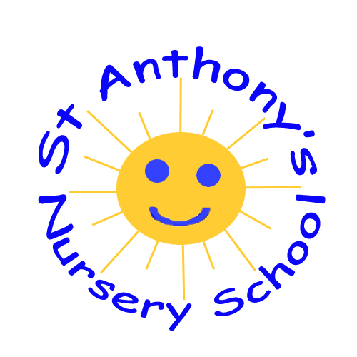

Dear Parents/Carers,
Welcome back to a busy half term in Nursery with lots of exciting things planned in the run up to Christmas.
Thank you for your participation in our settling in meetings last month. We hope you found it informative and we know you are as proud as we are at how our children have settled into their new routines. Written reports were sent home for you to sign and return as soon as possible. Thank you to those who have returned these already.
Thank you for your continued support with our snack fund as we rely heavily upon it to purchase resources and organise upcoming events for your child.
Warm regards,
Marie-Claire McIlroy

November Newsletter 2023
- Monday 6th November: School closed for staff development day
- Thursday 9th November: Jump, jiggle and jive in school for fun fitness activities(normal school day)
- Monday 13th November: Children can wear odd socks to mark the beginning of anti-bullying week
- Friday 17th November: Children can wear pyjamas to mark Children In Need day

Upcoming events in December
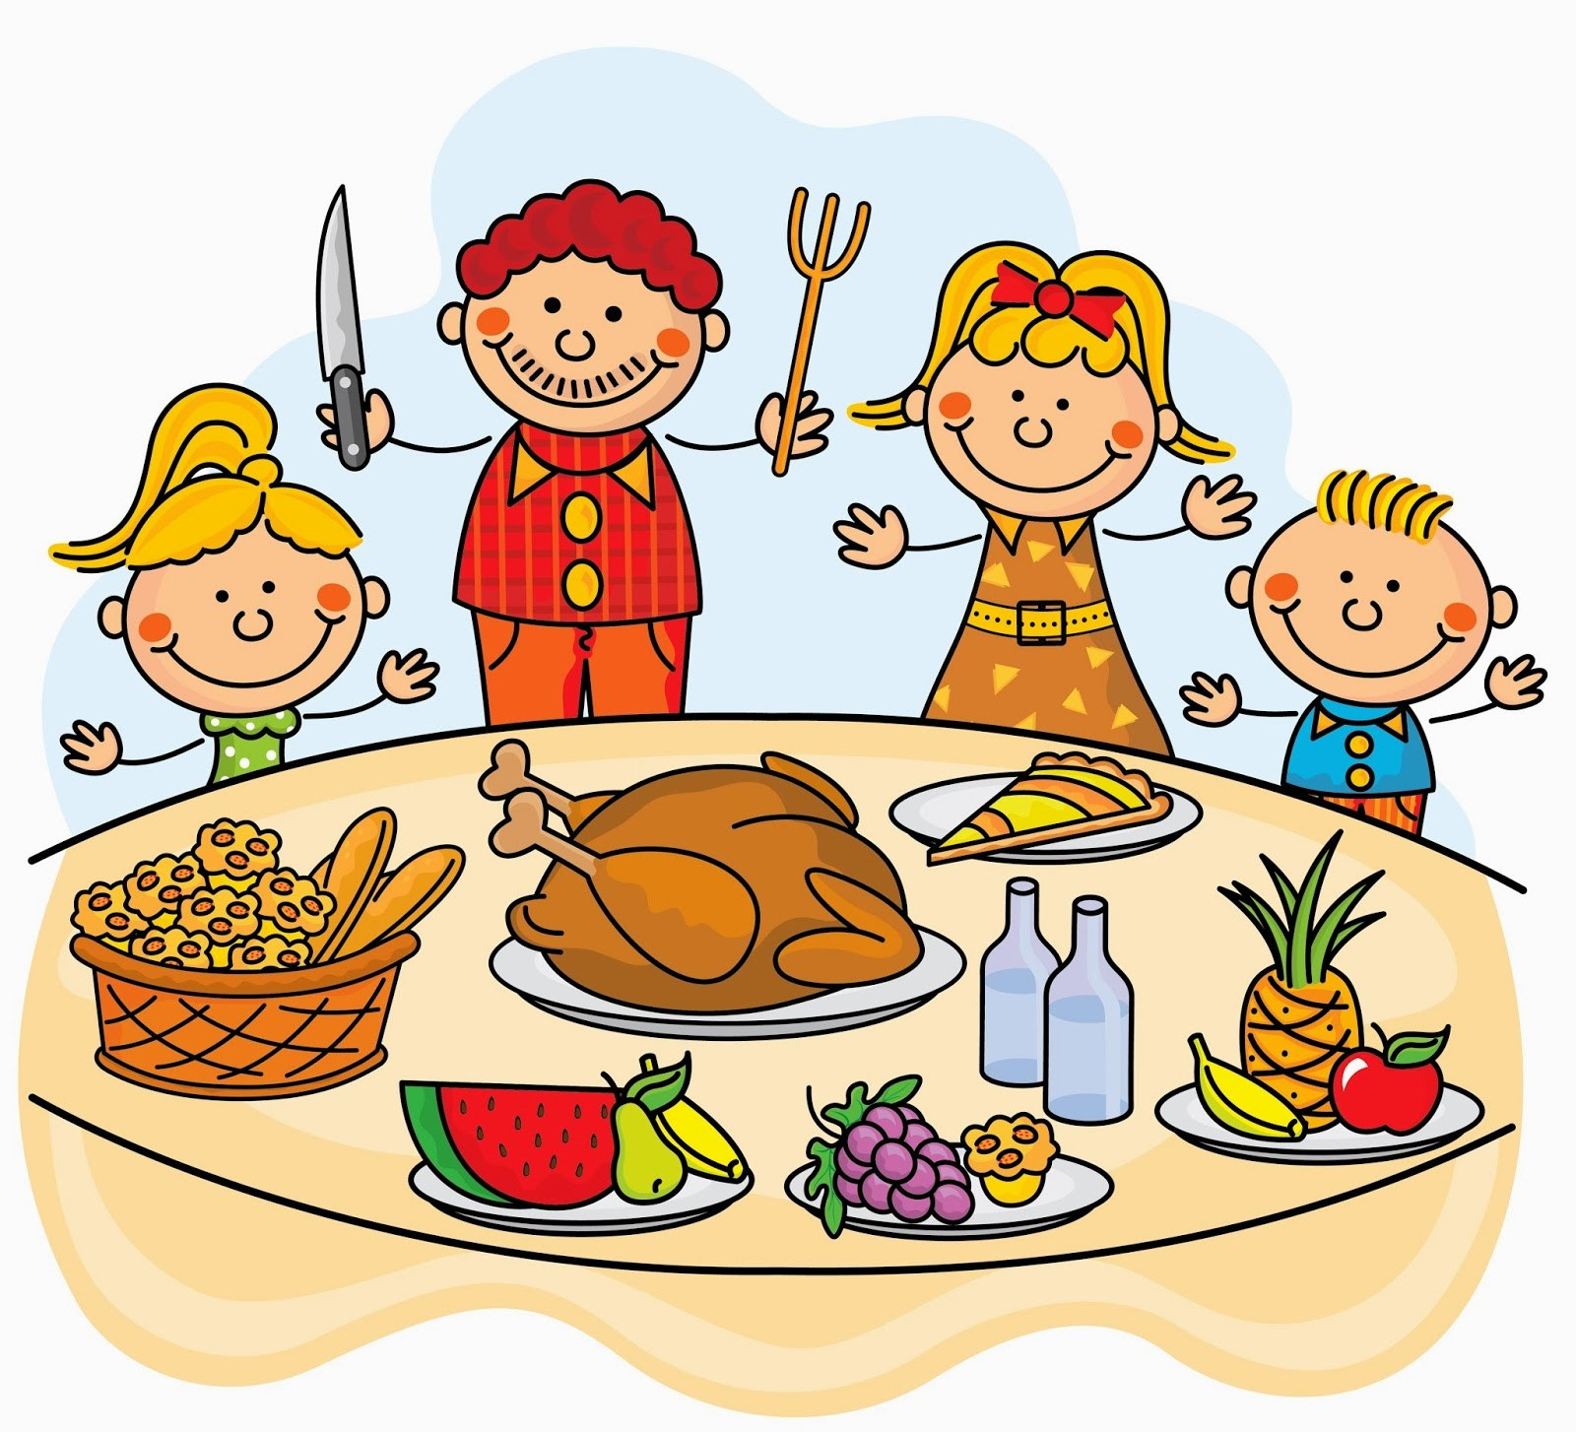
School Christmas dinner:
- Thursday 7th December** please inform a member of staff if your child is hoping to have Christmas dinner before Friday 17th November so the canteen can organise numbers
Christmas Concert:
- Wednesday 13th December: Mrs Gamble's class at 1100 **children go home straight after concert-no dinners/lunches for Rainbow Room (Normal school day for Butterfly Room)
- Thursday 14th December-Mrs McIlroy's class at 1100**children go home straight after concert-no dinners/lunches for Butterfly Room (Normal school day for Rainbow Room)
Open day:
- Wednesday 20th December 2-4pm **School finishes at 1200 (no dinners/lunches)
Mr Hullabaloo/Christmas Party:
- Thursday 21st December: School finishes for Christmas holiday (normal school day)
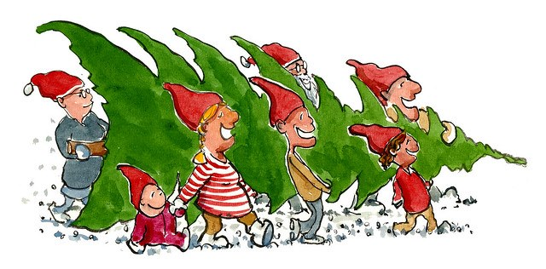

Theme: Day and Night/Dinosaurs
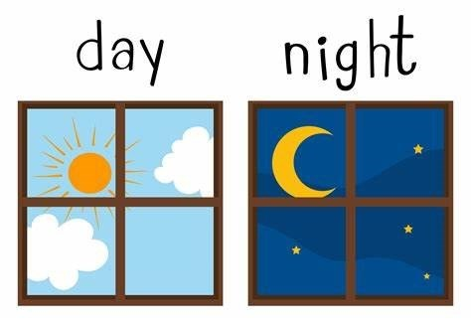
- identifying differences between day and night
- discussing nigh-time routines and how to stay safe during darker days
- Identifying dinosaurs and their habitats
- singing topical songs
- focusing on dinner routines. Please encourage your child to use a knife, fork and open cup properly to promote their independence
Some of the songs we are learning:
https://www.youtube.com/watch?v=MB4Ty1QEKLw
https://www.youtube.com/watch?v=sJiw-edttDY
https://www.youtube.com/watch?v=FHFOO4s3DTk
Congratulations to Fraser Kirkpatrick who won a prize for his painting in the Antrim In Bloom Art Competition
Happy Birthday to:
- Orla McKeown 9th November
- Finn McNeill 20th November
- Peter Dickson 21st November

Contact Details
Phone: 02828278645
Email: stanthonysnursery@yahoo.co.uk

